Nama : Aulia Eka Wulan Ardani

Nim : 071911633006

**Bukti upload video ke Instagram**

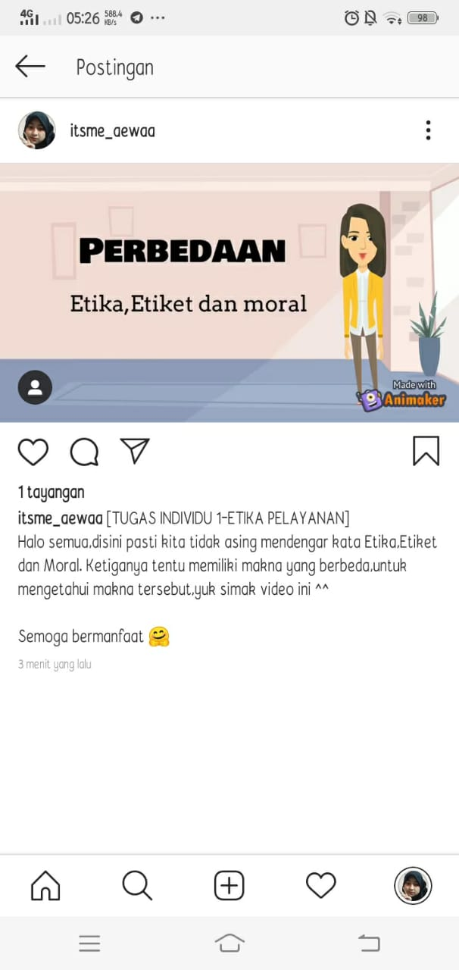

Link Video : <https://www.instagram.com/p/CFA0xQpJxbR/?igshid=1889upmearbqq>

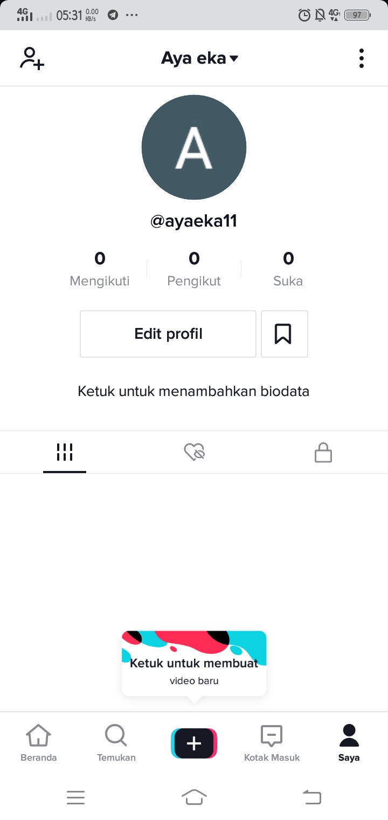Profil Tik Tok

Link Profil : https://vt.tiktok.com/ZS59nyQ6/